Voith Digital Solutions Holding GmbH, Postfach 2000, 89510 Heidenheim, Germany |  | Voith Digital Solutions Holding GmbH  St. Pöltener Straße 43  89522 Heidenheim, Germany  Tel. +49 7321 37-0  Fax +49 7321 37-7000  www.voith.com
To the Supplier of the
Voith Digital Solutions Group

 | Your ref.  Your message  Our ref.  Phone  Fax  Date  E-mail | 07321-0  2017-04-06  DSG-VbmeldungHDH@voith.com
Instructions for Completing of the Excel File
,,Voith Digital Solutions Supplier Interface /
Dispatch Info”

Ladies and Gentlemen,

In this document you find a support for completing the above mentioned Excel File. „Voith Digital Solutions Supplier Interface / Dispatch Info“. For the purchase orders of the Voith Digital Solutions Company, if we have a direct delivery and if the respective instructions are listed in the order form you have received, the dispatch notification has to be made by this way.

The specified file is provided in the supplier portal on our homepage.

The following link takes you directly to the download area.

http://voith.com/en/group/purchasing/downloads/digital-solutions-75740.html

The fully completed file has to be sent to the P.O. address specified in the purchase order form. We recommend not to use templates of already used dispatch notifications, but to download the most current version from our homepage for each new notification.

For questions regarding the completion procedure of the file please refer to your contact person from the procurement or shipping department of the Voith Digital Solutions group or contact person mentioned in the header.

Sincerely yours,

Shipping & Purchasing Team DS

Table of contents

1. General
2. Explanatory notes on the entry fields
3. Data transfer from the purchase order
4. Packaging types

1. General

▪ The Voith Digital Solutions purchase order is existent.

▪ The completion language English has to be observed.

▪ Only one file has to be completed for each purchase order and each delivery.

▪ The file may only consist of the existing sheet (content).

▪ Please enter each purchase order item as a separate line. An additional item for a purchase order item has also to be entered as a separate line.

▪ The columns supplier material reference, supplier colli number and sup- plier order number are being considered for your disposal and should simplify the assignment.

▪ Please do not change the file format, this format is processed systemati- cally in our company.

▪ Please use only the template provided in the supplier download area on our homepage.

▪ The packaging assignment must be defined in each line.

▪ The packaging data are to be listed for each item, they may not differ for the very same package.

2. Explanatory of the entry fields

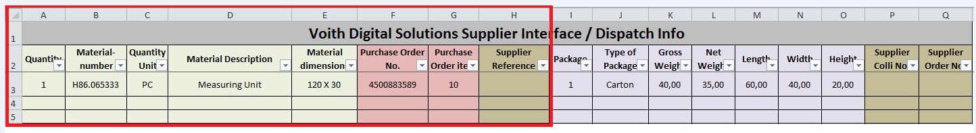

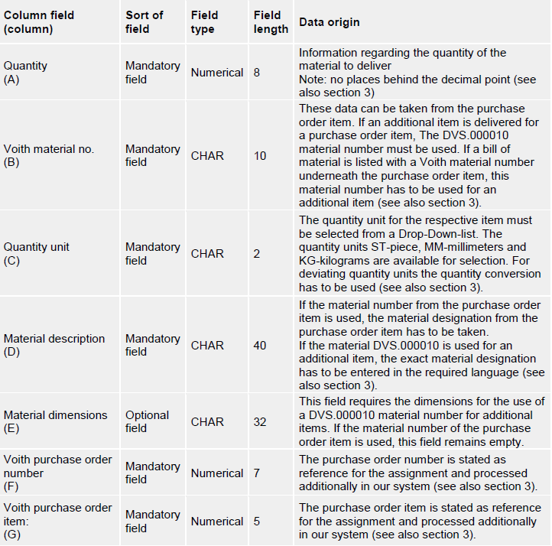

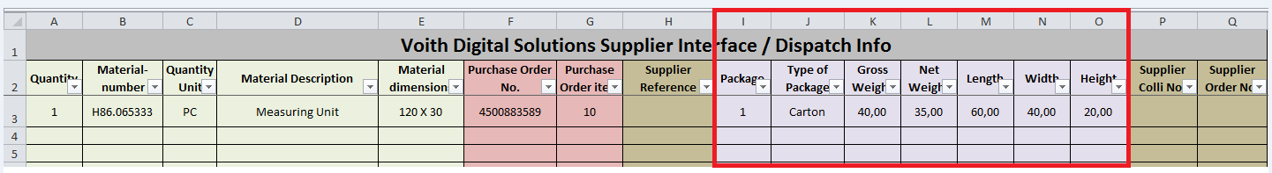

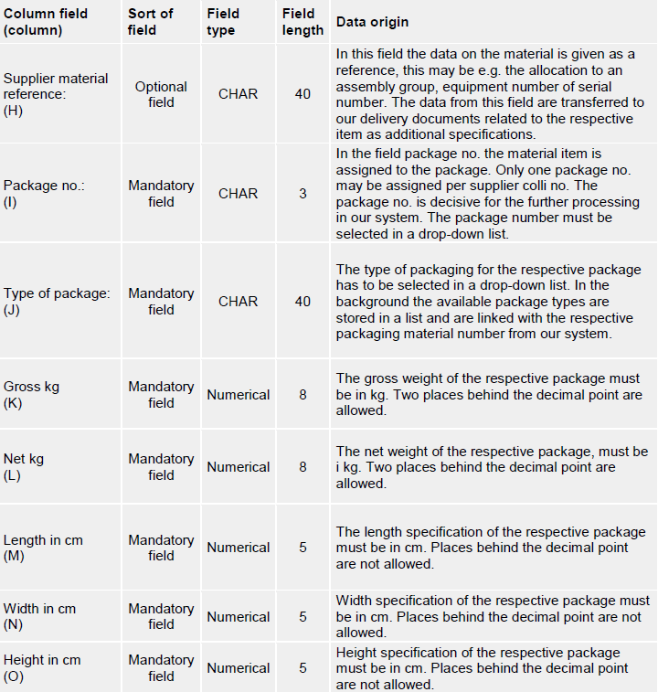

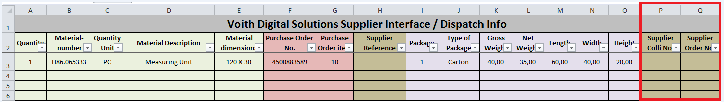

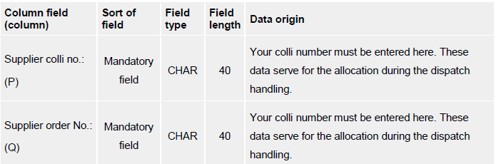

3. Data transfer from the purchase order

Example data transfer from the purchase order
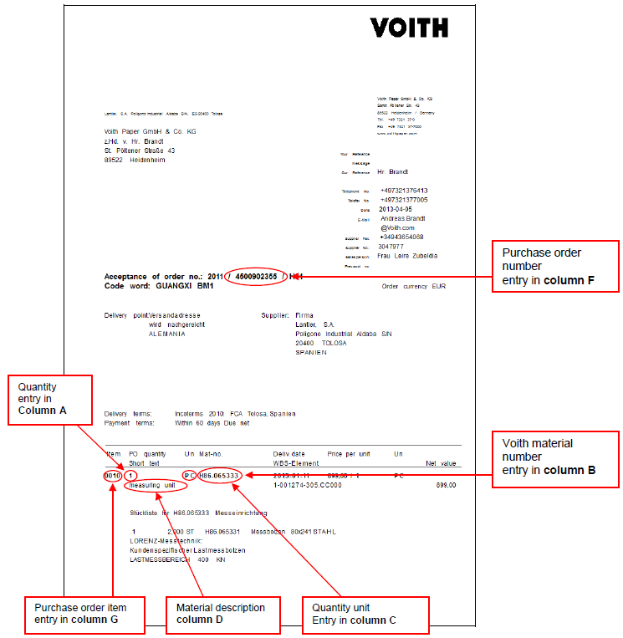

Example data transfer of an additional item to a purchase order item
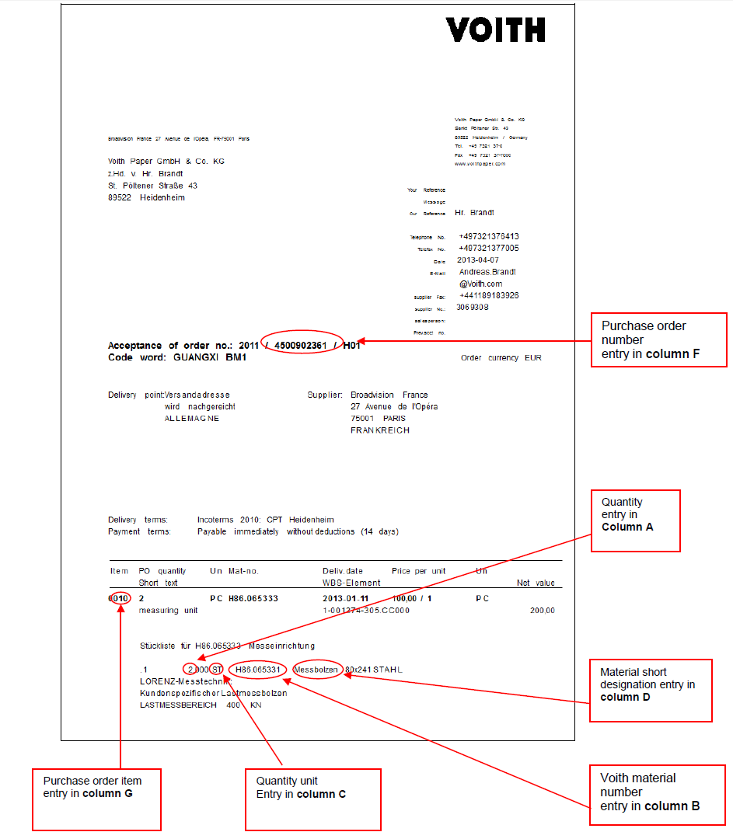

4. Packaging types
The following packaging types are available in column "J" for selection.
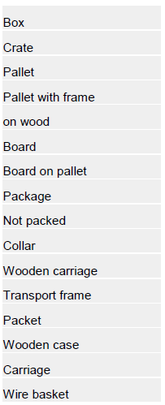

In case the used packaging type is not listed, please remark explicitly in the dispatch notification. This specification must explicitly be remarked in the dispatch notification which is forwarded to us via email or fax, including assignment to the item, colli no. must be mentioned as well.

