PACKAGING MANUAL

for deliveries to the J.M. Voith SE & Co. KG plant in Kiel
In order to enable effective handling of the large quantities of goods arriving at our plant in Kiel, we have to use largely standardised packaging material.

The use of our packaging is integrated into the entire material flow - from the packing process at your premises as a supplier, through shipping, transport, goods receipt, possible processing in production, and warehousing, all the way to removal for assembly. It is therefore very important that you pay close attention to the systems and procedures described in this manual, as they result from this integration.

In this manual, we have compiled the descriptions and instructions related to the use of our packaging. These should be mutually beneficial in your deliveries to us.

J.M. Voith SE & Co. KG | VTA
Uferstraße 80
24106 Kiel

Tel.: 0431 / 25959 - 0 Fax: 0431 / 25959 - 999

TABLE OF CONTENTS
1 General Information - 3 -
2 Description of Packaging Approved by Voith - 4 -
3 Requirements for Packaging Materials - 5 -
4 Packaging Instructions - 6 -
5 Labelling of Goods and Packaging - 7 -
6 Palletizing Specifications - 7 -
7 Barcode Delivery Note - 8 -
8 Billing of Packaging - 8 -
9 Pick-up Notification to Schenker - 9 -
10 Packaging in Detail - 10 -
11 Application Examples for Comb Insertes & Interlayers - 13 -

General Information

Packaging is today an important factor for efficient logistics. In order to live up to this significance, we aim to establish an effective and economical goods handling system together with our suppliers.

We hope that, as a supplier, you will find answers on the following pages to questions that may arise in connection with the use of packaging.

Should you require further information, we will be happy to assist you.

Contact person: Maik Horstmann, Tel.: 0431 / 25959 - 542

Objective of the Packaging System:

- More efficient handling
- Flexibility
- Lower costs
- Effective protection of the goods
- Delivery reliability

Unit consistency

Unit consistency means that the same article number is always packed in the same manner (if necessary, supplemented by palletizing diagrams). This allows the goods handling system to operate in a standardized and systematic way.

Mandatory Application

This packaging manual governs the use of packaging approved by Voith. Any deviations from these specifications require written approval prior to delivery.
Exception: small consignments shipped via the DHL supplier portal in accordance with our shipping instructions stated on the purchase order / delivery schedule.

Description of Voith-Approved Packaging

Components of a pallet unit:

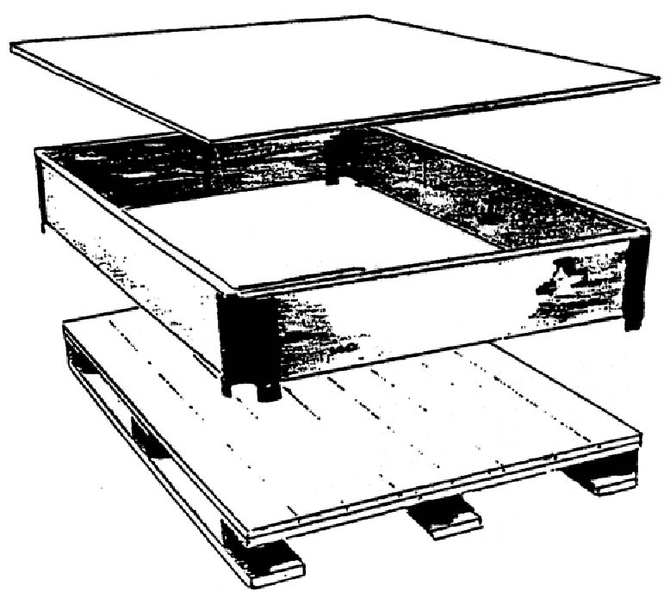
Euro pallet
Euro frame (collapsible)
Interlayers

Description | Dimensions L x W [mm] | Height [mm] | Weight [kg]
Euro pallet (wood)  Euro frame (wood)  Interlayers (plastic), large  Interlayers (cardboard), large  Interlayers (pressed wood), large  Comb insert, long, high  Comb insert, long, low  Comb insert, short, high  Comb insert, short, low | 1200 x 800  1200 x 800  1140 x 740  1140 x 740  1140 x 740  1150  1150  750  750 | 144  190  6  4  4  180  55  180  55 | 20  8,5  5,0  1  1  1,6  0,35  1,0  0,25

Please note:
Maximum weight per pallet unit (gross): 700 kg
Maximum number of frames per pallet: 3 units

Requirements for Packaging Materials

The packaging material must be designed in such a way that safe transport and safe handling with standard material handling equipment are ensured.

In principle, Euro pallets and mesh boxes are exchangeable, except for damaged ones. In the event of non-exchange, the stock will be recorded in a packaging account at the collecting Schenker branch. The exchange or non-exchange must always be confirmed by the collecting driver.

All other packaging materials and required consumables, such as steel strapping, plastic bags, corrosion protection paper, etc., must be provided by you free of charge (use of corrugated cardboard is not permitted).

The use of special and inner packaging must be taken from the part-specific packaging instructions.

Remarks:

In order to jointly achieve an economical material flow, we reserve the right to return deliveries that do not comply with these regulations at your expense.

Packing instructions

In general, the goods must be secured in such a way that no damage can occur during transport. The goods must be preserved in accordance with the order and delivery specifications to ensure protection against corrosion.

The surfaces of painted parts must be protected with double-wall corrugated cardboard. Plastic strapping used for securing the load must be applied over the cardboard in order to prevent damage to the paintwork.

When designing the packaging, it must be ensured that the goods are suitable for stacking. Sensitive goods that are not stackable must be labeled with the pictograms “not load-bearing”, “not stackable”, and, if applicable, “protect from moisture”, in order to avoid transport damage. The available packaging volume should be fully utilized, i.e. pallets should be completely and uniformly loaded with the goods, if necessary in accordance with the palletizing specifications (see example below). If possible, the goods must not overhang the pallet; this means that the pallet must be larger than the goods.

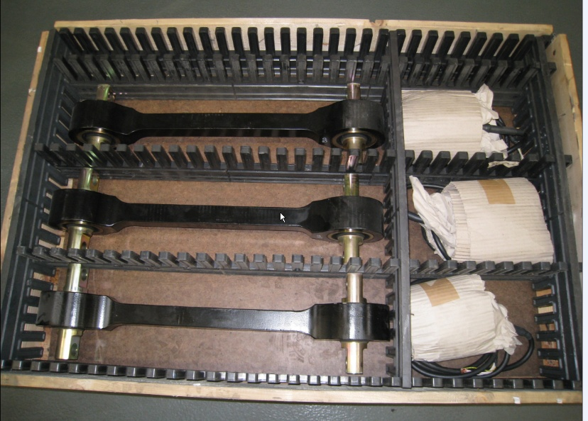
Example: 2 layers = 6 parts = 3 sets

For packaging-related questions, please contact:

Phone: 0431 / 25959 - 542 Maik Horstmann

Labelling of Goods and Packaging
In order to ensure identification and traceability of supplier parts, it is mandatory that pallet units are equipped with valid goods tags.
Our carrier, DB Schenker, is responsible for proper labeling.

However, if the Voith order requires a delivery of initial samples, the delivery unit must be labeled by the supplier with a yellow goods tag marked “INITIAL SAMPLE”.

This goods tag must be attached to the delivery unit (carrier). In addition, the respective goods must be marked as an initial sample (supplier).

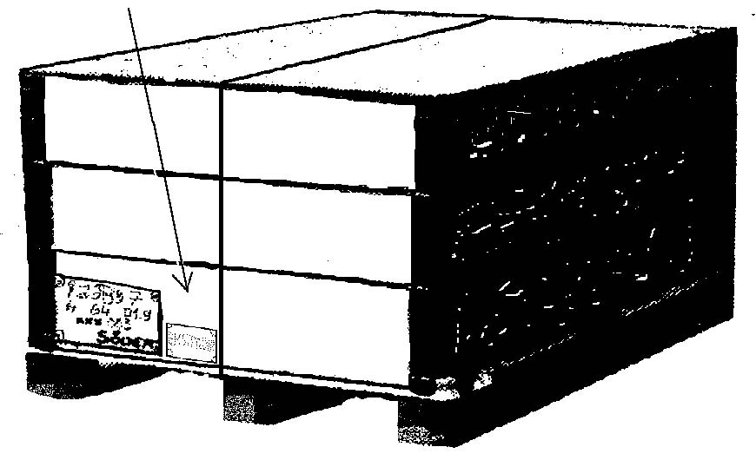

The initial sample label must not be attached above or below the strapping.

Palletizing Specifications
For certain materials, additional palletizing specifications will be provided as required together with the purchase order / delivery schedule.
Example:
241.00737510 cooler module front incl. balancing weight DB RAL 3020

Barcode Delivery Note

For deliveries to our plant, the use of barcode delivery notes is mandatory.
The delivery note must be enclosed with the shipment as the accompanying shipping document. It is an integral part of our new logistics concept and leads to a significant simplification of goods receipt processing.

8 Billing of packaging

As a supplier, you are responsible for the proper use and handling of the packaging. Please note that you are also responsible for ensuring that the appropriate packaging is available in order to guarantee on-time delivery.

Euro pallets are exchanged via our forwarding agent DB Schenker.
Wooden frames are not exchangeable packaging (“load carriers”) and are therefore neither exchanged nor recorded by the forwarding agent.

9 Pickup Request to Voith Logistics

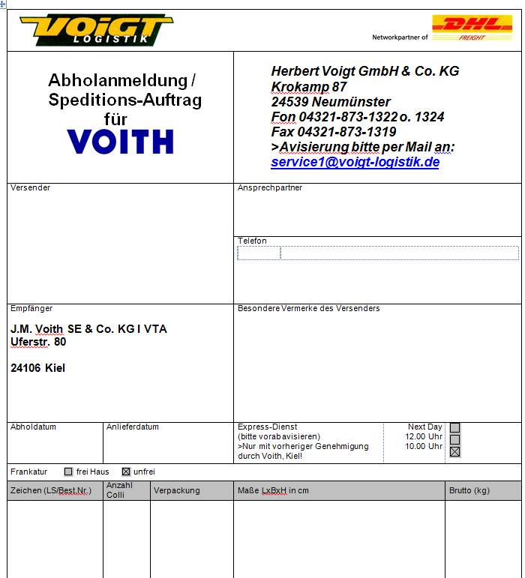

10 Packaging in detail

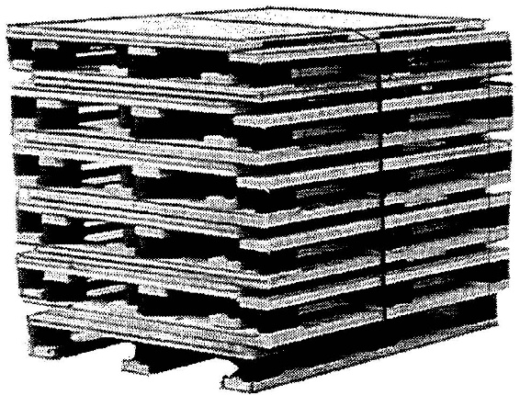
Euro pallets:
Exchange via forwarding agent

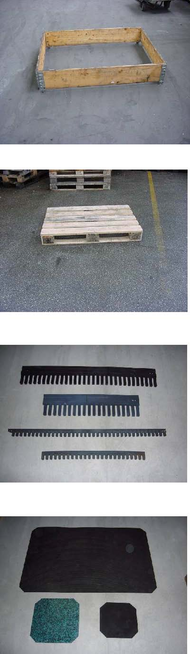
Comb inserts with a height of 180 mm:
Long comb insert: 1150 mm
Short comb insert: 750 mm

Comb inserts with a height of 55 mm:
Long comb insert: 1150 mm
Short comb insert: 750 mm

(To be procured by the supplier if required – disposable packaging)
Plastic interlayers:
Large: 1140 x 740 mm

(To be procured by the supplier if required – disposable packaging)

Euro wooden pallet
Dimensions: 1200 x 800 x 144 mm
Tare weight: 20 kg
Maximum load: 700 kg
(Exchange via forwarding agent)
Euro wooden frame
Dimensions: 1200 x 800 mm
Usable height: 190 mm
Overall height: 190 mm
Tare weight: 8,5 kg
(return via forwarding agent after prior notification)

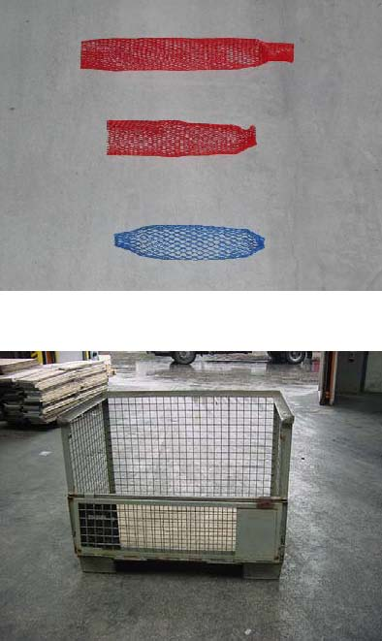
Euro steel mesh container
Dimensions: 1200 x 800 mm
Usable height: 800 mm
Overall height: 920 mm
Tare weight: 85 kg
Maximum load: 1000 kg
(Exchange upon delivery)
Stretchable rubber protection for round profiles/threaded rods
(To be procured b the supplier if required – disposable packaging)

11 Application Examples for Comb Inserts & Interlayers

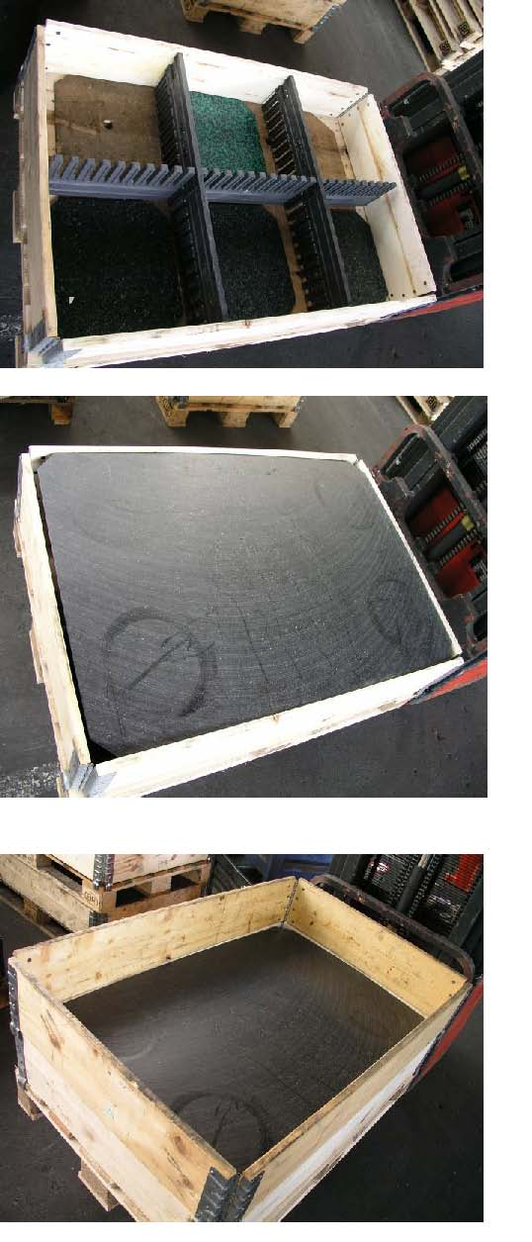
Euro pallet with euro frame and large plastic interlayers used as a cover

Euro pallet with two euro frames, an interlayer, and large plastic interlayers used as a base

Euro pallet with euro frame, comb inserts, and small plastic interlayers as a base

Please note that, as a supplier, you are required to comply with the regulations described in this manual.

We look forward to a cooperative and successful partnership with you.

J.M. Voith SE & Co. KG | VTA

Uferstraße 80

24106 Kiel

